**What is ServiceNow**

**Jeff from ServiceNow Simple explains ServiceNow is a software company that provides business enterprises with a cloud-based platform to manage their IT services.**

**Fred Luddy founded the company in 2003.**

**Apparently, Fred Luddy got the idea to start the company when he became irritated by the inefficiency of the traditional information technology department.**

**He further explained the features of the ServiceNow platform, saying that it works over the cloud to provide all applications, platforms, and infrastructures necessary to easily express any requirement of business IT.**

**He finally mentioned that ServiceNow is headquartered in Santa Clara, California, with staff spread out all over the world.**

**ServiceNow Platform Overview**

**A video featuring a dialogue with Fred Luddy, the founder of ServiceNow, opened to a brief description by the man on how the company came into existence. Founded in 2004, business experts were meant to solve their problems with technology through the company; he would also mention that Fred Luddy, in 2021, was a college dropout and his net worth at the time was $1.3 billion dollars.**

**Next comes the ServiceNow platform detail: it defines it to be a delivery model for application platforms, in other words, an aPaaS model. He contrasts it with other cloud delivery models, such as IaaS and PaaS. What differentiates the ServiceNow platform is its basis on a single common database and data models that span an extremely large variety of business processes.**

**It also indicated applications and workflows that are being given in ServiceNow. These applications are scattered across four main workflows: IT, employee, customer, and partner workflows. All of these workflows have more subcategories and applications beneath them.**

**Generally, the video relates to the architectural framework of the ServiceNow platform. It has a multi-instance architecture wherein every customer has an instance that provides flexibility and control to large clients. The video talks about the availability and redundancy of the platform.**

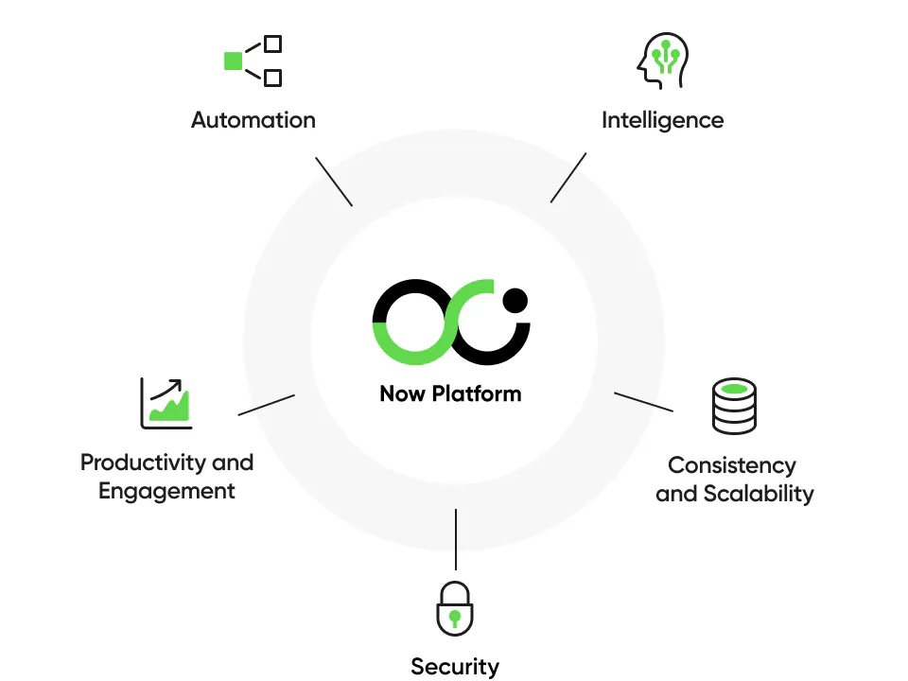

**ServiceNow User Interface Overview**

This is the third lesson of the ServiceNow Fundamentals Learning Plan. This lesson would focus on the ServiceNow User Interface that will be given to trainees. It includes the orientation on screen layout, location of components on the screen, availability of tools, and some commonly used tools like user menu, global search, connect chat, contextual help, system preferences, application navigator, favourites, browsing history. The video begins with a quick overview of the notes—some sort of cheat sheet to review before the certification exam—and then dives into the actual ServiceNow instances, going through all the user interface components.

Specifically, it covers the following in lesson 1 & 2:

Lesson 1: Introduction to ServiceNow

Therefore, ServiceNow is a cloud computing platform purposed to help a host of other organizations by managing and overseeing the operations of IT and delivering services. This class will delve deep into how automation within IT can be hugely realized using ServiceNow in automating a couple of processes to maximize efficiency.

Background History of ServiceNow: This section attempts to encompass the background history, right from the inception of ServiceNow, to its charted growth over major milestones over time. This could discuss the vision and mission of the organization as well as its unique methodology toward managing IT services.

Key features of the ServiceNow platform: This section should cover key characteristics and capability areas of the ServiceNow platform. Things considered would be, for example: incident management, problem management, change management, asset management, the service catalogue, while this can also check whether the platform is flexible and scalable enough, and what the option for integration with other systems is.

ServiceNow applications and workflows: this will delve into the different applications integrated into the ServiceNow platform and the workflows that characterize the platform. This will highlight their ways of use in optimizing given business processes, for example, in human resources, facilities management, and customer support. Ideally, ways in which workflows can be customized to meet the explicit needs of a company will be explained.

ServiceNow Architecture: This section will further elaborate the above analysis into the cloud-based infrastructure and multi-instance capabilities of ServiceNow. It might also discuss the scalability, reliability, and security features of the platform.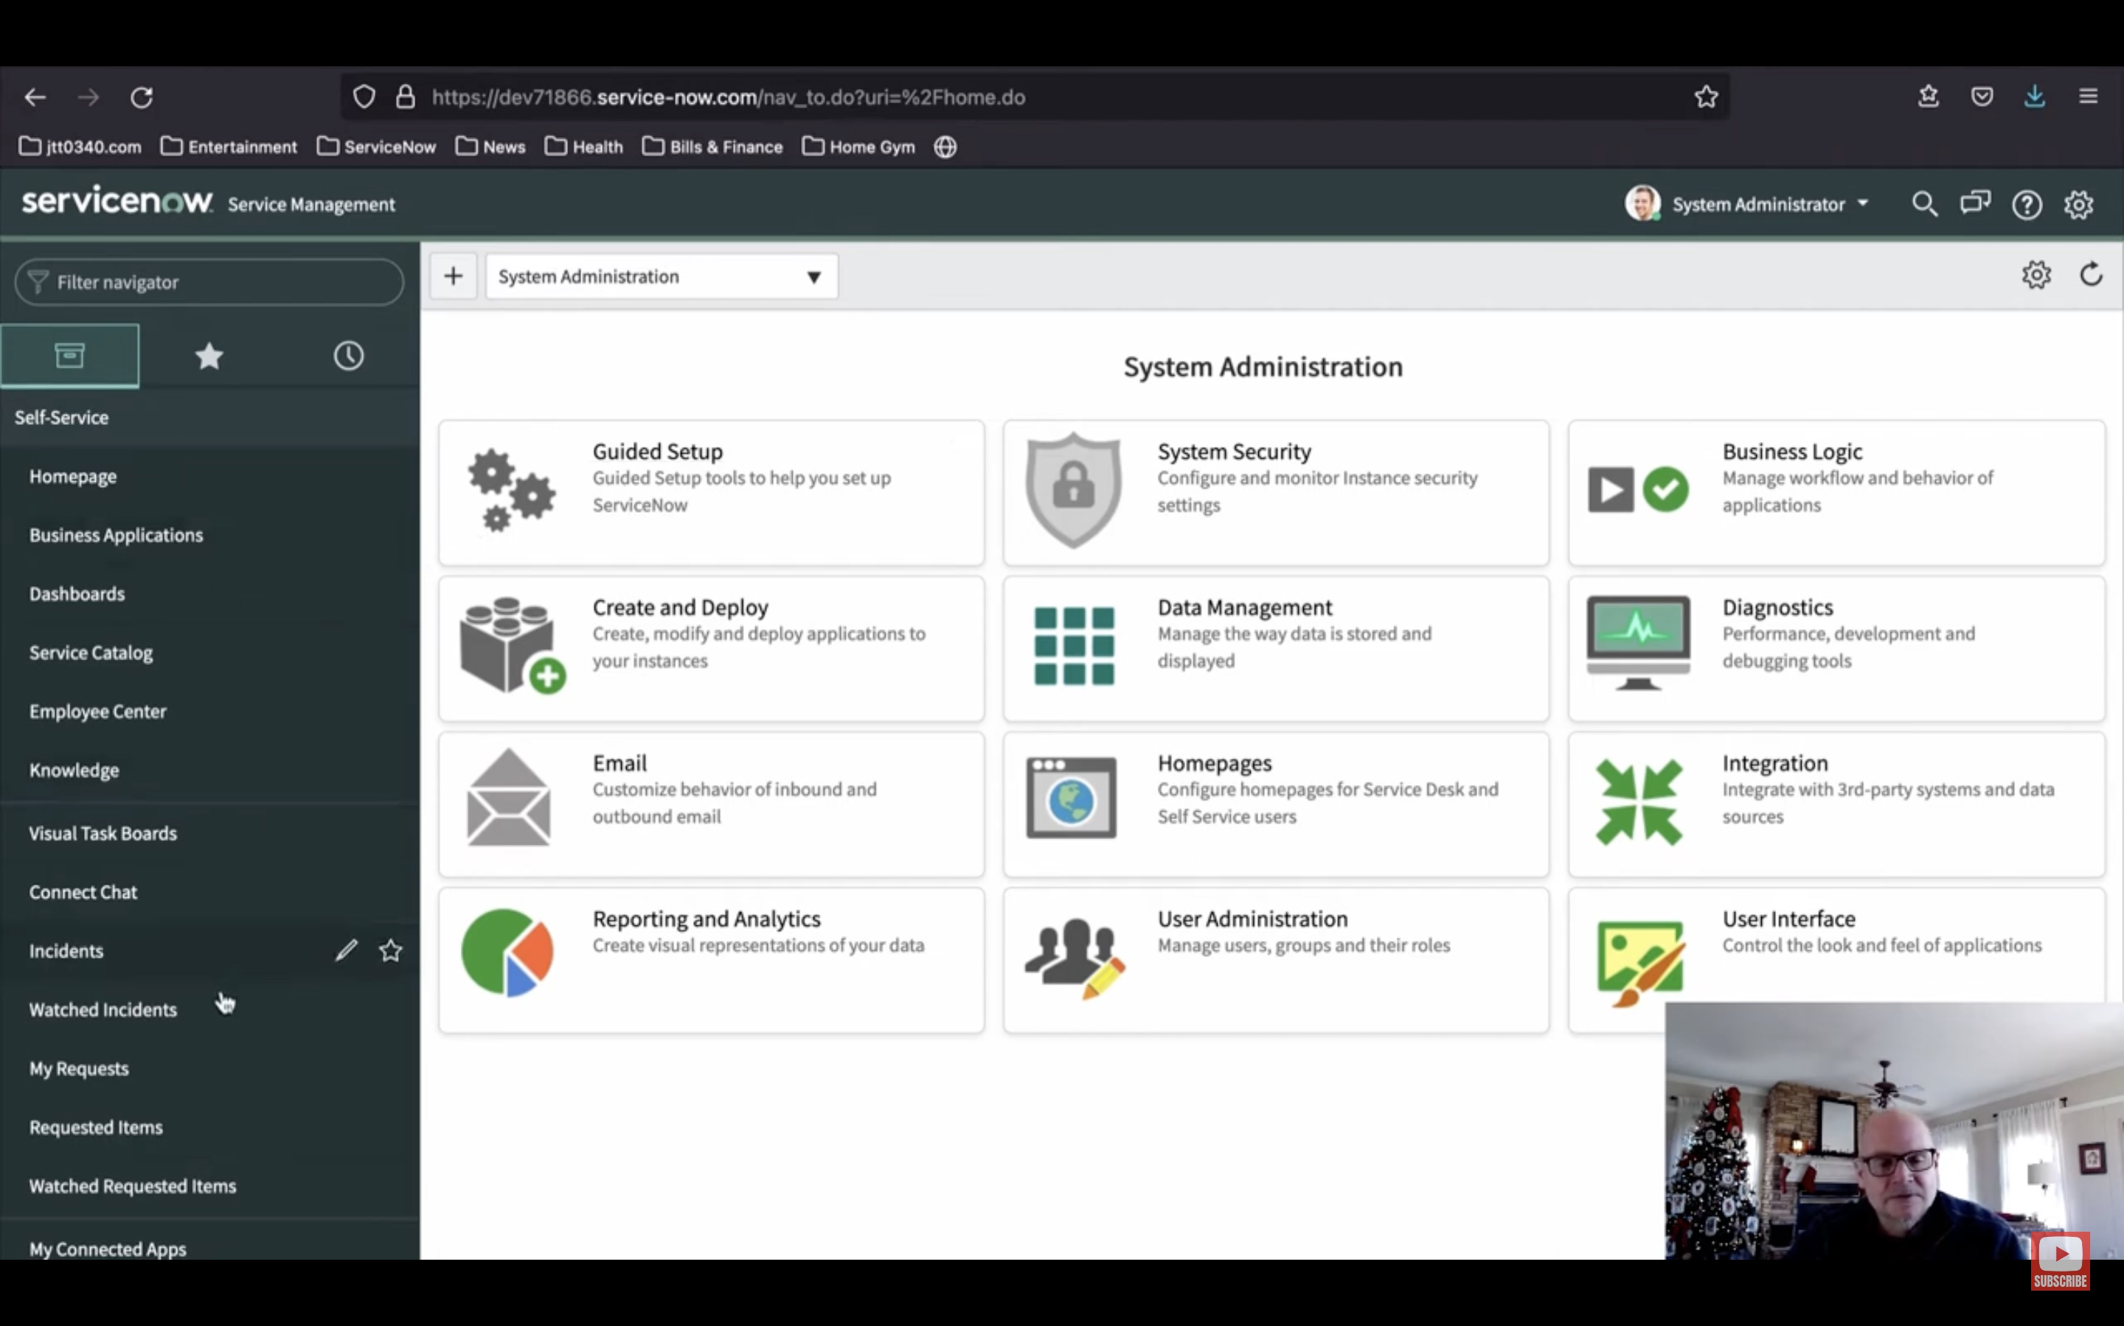

Lesson 2: ServiceNow User Interface Overview

Setting Up the ServiceNow Interface: This instructional module describes the essential setup of the ServiceNow interface. It includes the navigation menu, header, and primary content section. This may even form the exercises around how someone can navigate to other pages and applications across the platform.

Interface elements of the ServiceNow user interface: this class will demonstrate the numerous interface elements that might constitute a ServiceNow user interface, including forms, lists, and charts. The documents describe how one works with such elements by creating new records and editing existing records, filtering information. Lessons: The tools should never be changed. They are very vital in enabling the user to get introduced to the various tools which come built in by the ServiceNow user interface. This may be covered from the angle of user menu, global search, connect chat, contextual help, system settings, application navigator, favourites, and history. Additionally, it should be elaborated on the best way it can be utilized to enhance one's productivity and effectiveness.

**ServiceNow Branding Overview**

This video in lesson four of the ServiceNow Fundamentals Learning Path on the ServiceNow Branding Overview explains what ServiceNow branding is and describes why branding would be used within the ServiceNow platform.

Branded elements in ServiceNow have to do with the changes in visual settings: making a user feel that he is using an interface that has been developed in his organization. That, in general, may mean custom logos, organization typefaces, and corporate color schemes, among other things.

This can mean that ServiceNow branding may lead to group identification that is compatible with the general identity of the organization. Makes one feel comfortable and confident when using the tool. This branding speeds up the linking of users with the tool, as it identifies itself with a method common to them in an organizational setup.

Guided Setup is the application component that guides a user through a step-by-step setup of applications and modules inside ServiceNow.

• The ServiceNow Portal is another opportunity for branding the user interface and really making it a little more like your company. A widget-based tool, you can simply drag and drop widgets onto the screen to put together the user interface.

It is a UI Builder, widget-like, close to WYSIWYG Editor, in which you will be able to do real screens. Items such as buttons, headings, report sections, and others will be added so that you design the page or screen to look the way you want it to.

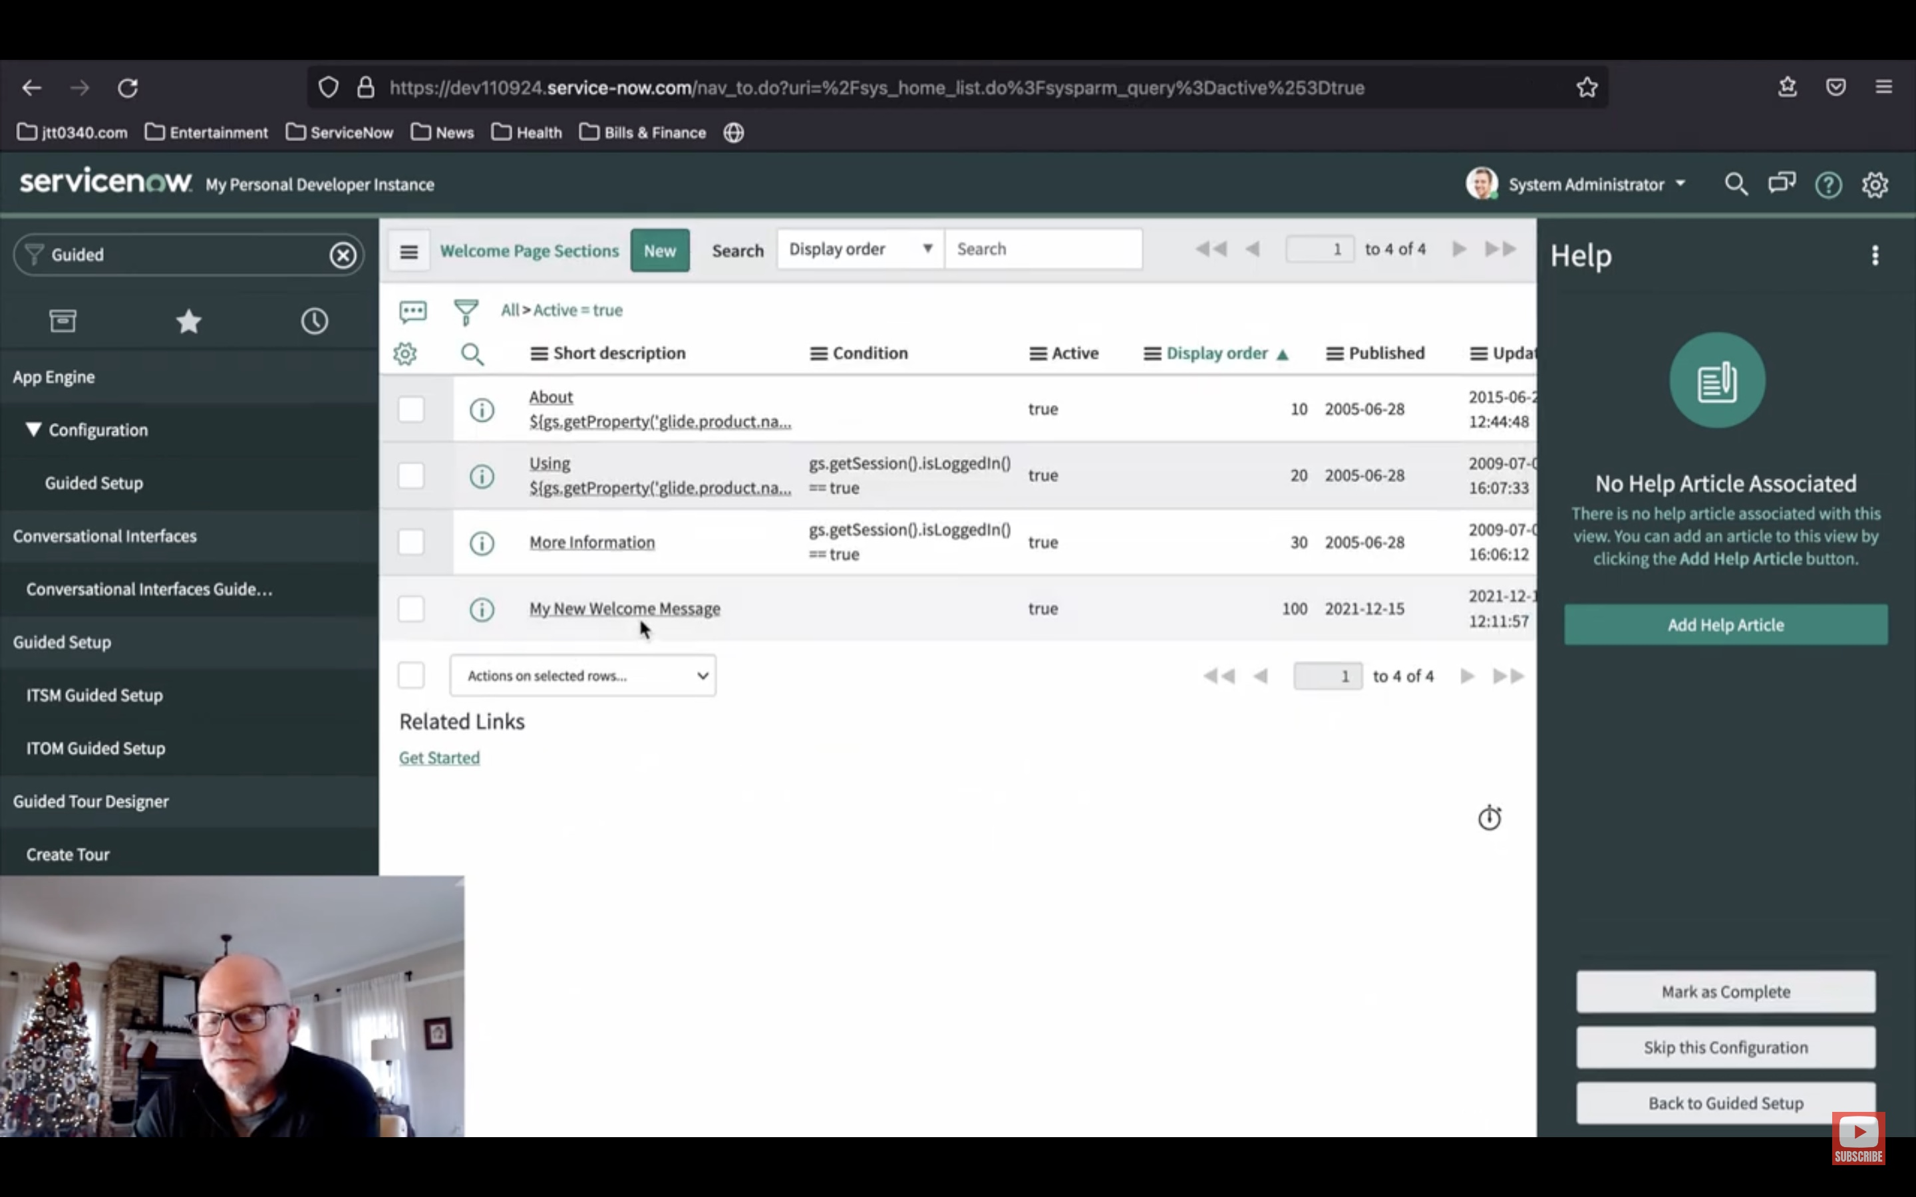

**ServiceNow Lists and Filters**

This video tutorial by ServiceNow Simple is on ServiceNow Lists and Filters. It elaborates on the notion of list views, which are the ways through which data kept in the ServiceNow database tables is represented. Later, it elaborates on how filters can be used to search and report data presented on the list.

List views are system-generated user interface pages showing lists of records coming from database tables.

Each list view corresponds to a table in the ServiceNow database.

List views also allow sorting, searching, filtering, and analysis of data in the list.

The list views can be accessed using the application navigator or by a list command preceded by a period.

You can also quickly open a list view of any table by typing its name followed by a period and the word list.

The table sys_db_object helps to maintain the existence of every table in a ServiceNow database.

It includes a title bar, list header, and data rows and columns.

This Title bar further houses the List Control menu, Search tool, Activity Stream icon, and Paging Controls.

The list control menu lets users choose saved views, organize data, specify how many records shall be shown per page, and refresh the list.

This feature helps one to look up any column for specific values.

It includes an activity stream icon, something akin to the record of everything done in that list.

Also added to the list header were the personalized list tool, condition builder, multi-column search, breadcrumbs, sort indicator, and column context menu.

The personalized lists tool gives you the ability to add, delete, or reorder columns from within the list view.

The condition builder allows applications of filters to the list with the use of operators and columns, with sorting.

The multi-column search facility allows searching for values across a number of columns at one time.

It's just the breadcrumbs of filters that have been applied to this list.

Level It also provides, from the context menu of the column, actions on single columns, such as showing a Visual task board, generation of Bar chart or Pie chart, and configuration of further advanced options.

The various options appearing in the context menu field allow for executing several actions on that individual field—like show matching records, filter out records, copy URL or Sys ID, assign tags to selected rows, and update selected rows. The List view provides the overall consistent structure across all list-related items in ServiceNow.

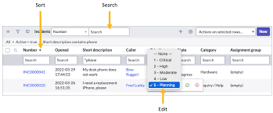

**Forms in ServiceNow**

It describes what forms are and how they work in allowing a user to view, edit, and update record information through ServiceNow. The clip goes further into the categories of the form fields, process of saving changes in a form, techniques to design and stay in a form, techniques that support navigating the form sections, related lists, and formatters, and the procedure to build and manage form views. In addition, it elaborates on the ways to further customize forms, add attachments to forms, and how to create and use form templates.

Forms are elements of the user interface in the ServiceNow platform that allow users to view, update, or add data to records.

There are equivalent forms in ServiceNow for each record type.

It should have a header bar, main section and sub-sections.

The header bar comprises the form title, form context menu, and more options button.

The main part holds fields responsible for viewing and collecting the data of the record's attributes.

The additional subsections include related lists and formatters.

It opens the context menu, where you can access form views, form configuration, and other features.

Options button that will get open various forms of templates and more options.

Different categories of form fields include string fields, Boolean fields, choice fields, reference fields, list fields, and journal fields.

There is an ability to save forms through the submit, update, or save button while making changes.

A new record can be added by using either the insert or insert-and-stay buttons.

Form sections permit grouping several fields with additional information into one common characterization.

The related lists are actually compilations from several tables that have relations to the record currently being viewed.

Formatters display information related to the record, such as the history of activities or attachments.

Views of the same form can be created and maintained in form views.

Further personalization of forms can be done by adding, removing, and reordering of fields using the form personalization tool.

Forms can be submitted with attachments by clicking the 'manage attachments' button.

Form templates help to automatically pre-fill fields in the record creation process.

Views can be added and modified in both the form design tool and the form layout tool.

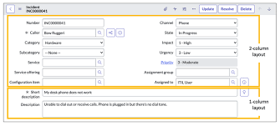

**A Hands-on ServiceNow Tool Demo**

He shows this tool with its function and purpose: ServiceNow. First, he describes what it is and how it works, and then he launches into a live demo of the tool, ServiceNow. He writes about how to log into ServiceNow, elaborating into how to navigate through its applications and user interface, how to use the search function, making favourites, navigating through all the Menu, using the knowledge application. Further in the article is a simple guide on how one can draw out information from the database of ServiceNow, how one can get his personal instance of it.

ServiceNow is a cloud computing platform developed for IT service management.

ServiceNow single-tenant instances are full-stack deployments of the platform.

To access ServiceNow, one must have an account linked to an associated URL.

The ServiceNow UI includes a navigation bar, contextual application pill, global search capability, the user menu, contextual assistance, an application scope selection tool, workspaces, history feature, favourites, and a comprehensive menu.

The All Menu in ServiceNow comprises all the apps included with this platform out of the box.

Knowledge management in ServiceNow supports a user to author and publish knowledge articles.

This is essentially all that the ServiceNow platform data bank encompasses.

A developer instance can be requested for one's own instance of ServiceNow.

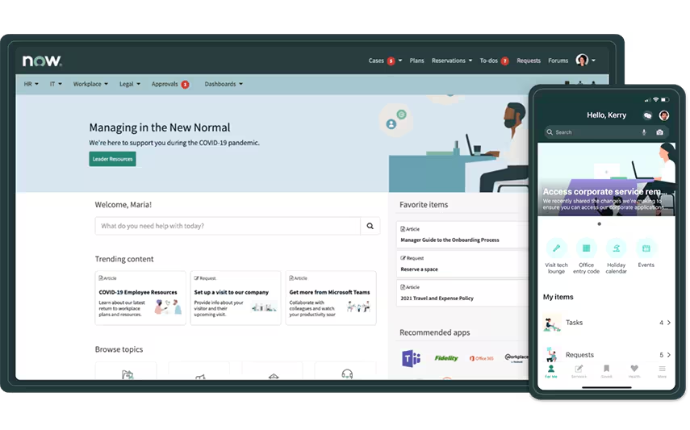

**Introduction to Importing Data in**

**ServiceNow**

Data Import to ServiceNow Through integrations, follow these steps:

Establishing a data source involves defining the source of the data.

Create an import set that contains a direct one-to-one relationship for the source data and the staging table.

Create a transform map, or a set of rules for data transformation as it goes through an import.

Create a field map to align the fields in the staging table with those in the target data store.

Schedule the data import. He added that the source data entity was the data to be imported, and the target data entity was where the data would be loaded. He, further, introduced the concept of the staging table which is supposed to be an interim table that is created automatically in the course of the loading process of the data to host the data.

**Creating a Data Source in ServiceNow**

Data source is a definition of the source of any data that needs to be imported into ServiceNow, including such pieces of information as the nature of the data source, the geography of data possession, and the authentication information required for access to data.

Configuration of a data source within the ServiceNow platform involves the following steps:

Go to System Import Sets > Administration > Data Sources.

Click the 'New' button.

Complete the Name field. This is a name for the data source that will be used for reference in ServiceNow.

Data source Describe the type of data source. The possible data sources are: • File • JDBC • LDAP • OIDC • REST • Custom Script.

Complete the rest of the fields as applicable. The fields to be completed will vary depending on the type of data source you have selected.

By clicking the submit button, the data source is created and saved within ServiceNow. A data source can be used to import records into ServiceNow. Once that connection is made, it works through an Import Set: fields in the connected data source are mapped to respective fields in the table where data is imported in ServiceNow.

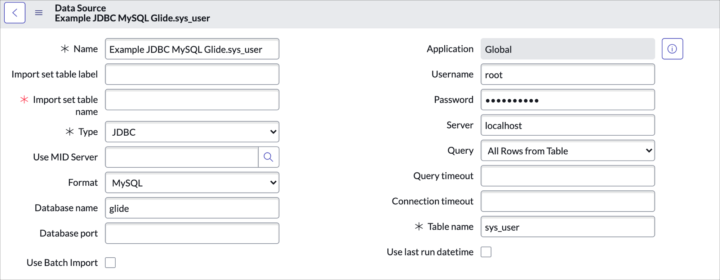

**Understanding Import Sets in ServiceNow**

It initiates with the review of a data source record where the label and table name are specified for the staging table. ServiceNow uses such parameters in the creation of the staging table at the time of the import.

It then shows how to make an import using the data source record. ServiceNow checks whether the staging table exists; otherwise, it creates it, connects to the data source, and uploads data into the staging table. This video confirms that the staging table was created with the given name and label, and the data upload was successful.

The video then proceeds to describe in more detail the import set table, which is one more item of ServiceNow standard functionality. An import set record may be thought of as a set or a grouping of records that results in a staging table after an import execution. In turn, the entries in the staging table hold a reference to a related import set record, and this gives ServiceNow the ability to manage and control the data loaded from different executions of the imports. The video then summarizes the steps covered from creating the record of the data source, testing the data source and import process, understanding the staging table to the import set table. The next step will configure how the data in the Staging Table should be loaded into the target table within ServiceNow.

**ServiceNow Transform Maps & Field Maps**

The process begins by summarizing previous stages in which a data source had been established and evaluated, thereby eventually allowing the importation of data into a staging table.

Mapping Transformation and Field Maps:

Field mappings are used to define the particular field in the staging table and how it corresponds to the same field in the target table. For example, it may be the field "name" in the staging table is matched with a field "username" in the target table.

The Transform Maps would transform by aggregating field maps into a consistent mapping strategy for the entire import process.

Custom Tables Creation:

This video guides how to build a custom table in ServiceNow, which would be used for storing data imported into the application. This essentially involves setting up fields that align with the structure of the data to be imported.

Setting up Field and Transform Maps:

This video demonstrates how to create a field map at an individual level by mapping the staging table's fields to the target table.

It also shows how to classify these field maps into a transformation map, hence providing a systematic approach in order to manage data importation.

Understanding and Utilizing Coalesce Fields

Coalesce Fields: This is said to be an option employed to detect duplicate records, thus ensuring that import would not result in duplication. The video tutorial explains the fact that any coalesce field—for example, a "name" field—can be selected in such a way that if another record with the same name does exist, the record will not be duplicated.

Final Steps and Testing: After creating the transform map and then the field maps, the video follows with all the activities upon completion of the full import to check that data flows from the source table into the target table. It also hints toward scheduling the imports so this process could be automated for future data transfers. The video is highly detailed with regard to every step; thus, it is helpful for those working with ServiceNow who need to understand and implement the process of data import using transform maps and field mapping.

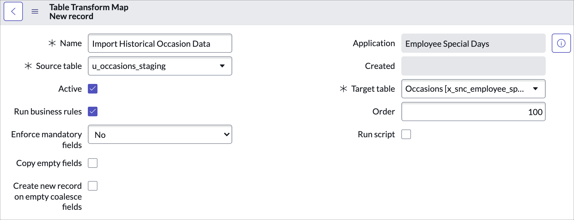

**ServiceNow Incident Management Tutorial and Task Administration**

Task management functions within ServiceNow are all oriented toward the task record table.

Explanation of how things like tasks are stored in the database; explain how incidents, changes, and problems are just a further extension of the main task table.

Task Creation and Management:

It examines how tasks are organized hierarchically in ServiceNow, including the processes by which incidents, change requests, and problems are initiated and overseen.

Introduction to assignment rules and how they automate the assignment of tasks to users or groups based on predefined conditions.

Task Assignment Rules:

Step-by-step guide on how to create assignment rules that will automatically route tasks to the right person or group.

How these rules are prioritized and executed in order is explained below.

Task Co-ordination Tools:

Examination of collaboration tools of ServiceNow: user presence and real-time editing features help multiple users participate in task execution at the same time.

Visual Task Boards: Introduction to visual task boards as a way of managing and organizing tasks visually using drag-and-drop. Different types of task boards, guided, flexible, and freeform, are explained here, coupled with an exploration into their potential use for effective task tracking and management.

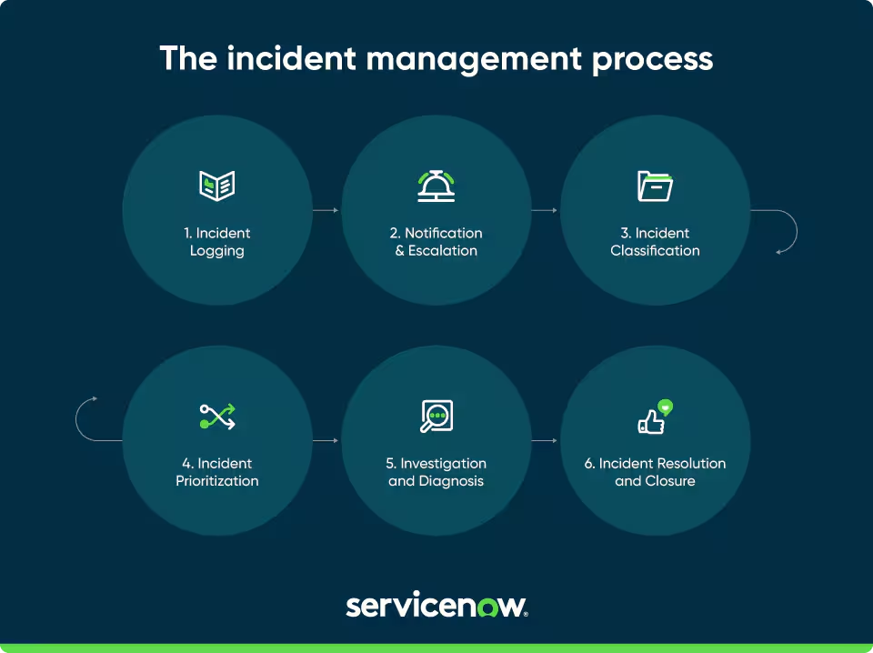

**ServiceNow Reporting Tutorial**

It illustrates that everything visible in ServiceNow is associated with a record in the database, and understanding this data-centric view is core to the ability to become somewhat competent with reporting.

2. Understanding the Report Table and Underlying Data Model:

The sys_report table is the base table that stores all saved reports. Every report that is created in the ServiceNow platform is retained as a unique record in this specific table.

Associated Tables:

Report Source Table - A table which houses saved queries for re-use in multiple reports, known internally as report sources, which serve the function of predefined instructions on how to obtain data.

Scheduled Email of Reports Table: Automatically creates reports and then sends them over email to specific users or groups of users on a scheduled-frequency basis.

The Users and Groups Table for Reporting: Manages the assignment of reports, allowing selected users or groups to receive and run reports as needed.

Dashboard Table: Allows the combining of reports with dashboards; it enables end-to-end views of data when combined with other widgets.

3. Report creation:

This video is a step-by-step guide to creating a new report.

Starting a Report: A report can be built from the "Create New" module in the Reports application, using ServiceNow Studio, or directly from the data list view to be analysed.

Report Fields: Such key fields are:

It is the title of the report.

Source Type: Indicates whether a table is used, or a specific data source used in the report.

Table: Indicates the database table from which the report will extract data.

Group By Field: Field by which the data will be grouped, necessary for creating meaningful views.

Types of Visualizations: ServiceNow has several ways to do visualization, such as pie charts, bar charts, line charts, histograms, heat maps, among many more. The video describes in detail each of these types and when they should be used.

4. Reports Management:

This tutorial discusses the managerial facets associated with reports:

Report Configuration: Several properties of reports can be changed, among which are the filters, grouping fields, and styling attributes. These types of configurations make it easier to configure reports for proper representation of data.

Field Description: The video explains the role of several fields in the report table, such as the filters (used for refining data) and the type of field (which is key in determining the format of visualization).

5. Scheduling Reports

the video on How to automate reports

You can configure the reports to run at set time intervals automatically—daily, weekly, or monthly—and deliver them by email to users or groups.

Setting Up a Schedule: This involves selecting the report, specifying the users or groups to receive it, and defining the schedule (e.g., first day of the month at midnight). The configuration also includes options for email content and report format (e.g., PDF, Excel).

6. Sharing Reports:

Collaboration is impossible without sharing:

Share Mechanism: Reports can be shared with the world, with a specific user, or with groups to enable the desired stakeholder to get report access.

Video Access Control: The video describes how to control the access of users to view and run reports by managing entries in the Report Users and Groups table.

7. Adding Reports to Dashboards:

Dashboards enable an integrated view that covers various reports and analytical appraisals.

Dashboard Integration: Reports can also be embedded into dashboards, where they are displayed with other widgets and performance analytic tools. This feature is necessary to enable one to get a complete view of the main metrics and data trends.

Create Dashboard Entries: This video demonstrates how to append a report to an existing dashboard and how to choose the right dashboard and tab to add the report to.

8. Advanced Functionality

The video goes over advanced options such as:

Conditional Execution: Reports can be scheduled to run only under certain specified conditions by setting up scripted conditions within the scheduling framework.

Edit and Enhance Visualizations: Advanced users can edit the details, settings, and configuration options of visualizations to tweak the look and feel of reports.

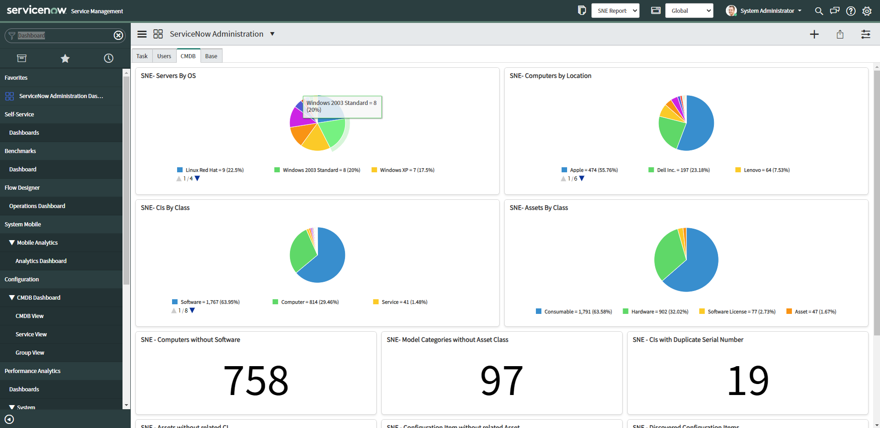

**What is Low Code No Code Development?**

Low Code/No Code (LCNC) software development refers to the process of building applications that include a minimal amount of hand-coding, and in some cases, none at all. These platforms provide a visual interface for manipulating and placing components, thus enabling the development of software by users with little to no programming experience.

How It Works

Low Code: This involves very minimal coding, usually requiring programming knowledge. It best suits the developer who wants to speed up development by automating some of the repetitive development tasks.

No-code: This means completely no code and allows non-developers to create applications using only visual tools and prebuilt templates.

Pros

Speed: Significantly faster development process compared to traditional coding.

Accessibility: Enables non-technical users to create and deploy applications.

Economically Efficient: Reduces the need for hiring specialized developers for simple development tasks.

Flexibility allows for rapid changes and iterative processing.

Cons

Limited Configurability: The systems may not support complex or highly customized applications.

Scalability: The applications developed on LCNC platforms may have some problems when scaling up.

Dependency: Users may get dependent on the platforms themselves at the cost of long-term flexibility.

Security Concerns: Implementation of strong security would be a challenge.

Career Opportunities

Citizen developers: Non-technical contributors to the development of applications with no-code platforms.

Low-Code Developers are developers who add programming to Low Code platforms in order to further advanced applications.

Platform Specialists: Low Code/No Code platform domain experts who can train others or optimize the processes.

Consultants: Professional advisers on the best LCNC platforms and practices for an enterprise.

